***CALTRACK- A CALORIE ADVISOR APP***

Dr Rakesh Kumar M Computer Science and Engineering Rajalakshmi Engineering College, Chennai, India [rakeshkumar.m@rajalakshmi.edu.in](mailto:rakeshkumar.m@rajalakshmi.edu.in)

# Abstract:

Diet control is one of the sub-procedures of fitness as well as a management technique for chronic conditions. I am not shocked that food has transformed from a big part of culture and tradition to now being a service that is delivered to your doorstep. This convenience has been coupled with high calories and several effects on our bodies. Current implementations that require individuals to record what they consume are also cumbersome. Caltrack is a calorie advisor app that uses Gemini Pro Vision an LLm by Google that people should use in order to manage the calorie intake. The purpose of this research paper is to discuss a new approach to calorie counting through the help of Gemini-pro-vision-visualrecognition technology that allows estimating calories by the products in the food – the user only needs to upload a photo of his or her food. In the current research, we employ a combination of Python libraries: dotenv, Stream lit, OS, Google, Generative AI, PIL, among others, to show how it has integrated various disciplines in the design of this application.

Diet control is one of the sub-procedures of fitness as well as a management technique for chronic conditions. I am not shocked that food has transformed from a big part of culture and tradition to now being a service that is delivered to your doorstep. This convenience has beencoupled with high calories and several effects on our bodies. Current implementations that require individuals to record what they consume are also cumbersome. Caltrack is a calorie advisor app that uses Gemini Pro Vision an LLm by Google that people should use in order to manage the calorie intake. The purpose of this research paper is to discuss a new approach to calorie counting through the help of Gemini-pro-vision-visual recognition technology that allows estimating calories by the products in the food – the user only needs to upload a photo of his or her food. In the current research, we employ a combination of Python libraries: dotenv, Stream lit, OS, Google, Generative AI, PIL, among others, to show how it has integrated various disciplines in the design of this application.

# INTRODUCTION:

Some of the newer developments relating to the convergence of AI are the use of LLMs for image processing. This project: LLM text and production of Large Image Models. They are deep learning models that have been trained on a massive corpus. The transformer is a deep learning model that has an encoder and a decoder, which enables the encoder to focus on the attention of the decoder and vice versa. It has the gemini pro vision and supports different python libraries like PIL (Python Image Library),Google.generativeAI,io,streamlit,os,dot env.The LLM is more flexible in the ever-changing field of AI. The same model could be used for tasks such as QA, document summarization, translation and word/sentence completion. AI chatbots will influence the way humans produce content and engage with search engines and virtual assistants.Image processing is concerned with treating an image and converting the said image into digital format and then performing useful operations on the digitized image. Most of the signal processing procedures employed by the image processing system treat the digital images as 2D signals.Gemini Pro can be described as a kind of a base for development processes for such libraries as dotenv, Streamlit, OS, Google. GenerativeAI, PIL, and pyttsx3. It is possible to use the tools mentioned above in order to enjoy the power of language and image recognition and develop an easy to use and effective application[6].This project is aimed at the determination of the energy content of a food or drink. The food and beverages that are taken contain energy needed to sustain the body in motion. For instance the body needs energy to breathe; it also requires energy to make the heart beat and to grow, and also for other physical activities including walking, jumping or running. This application is to determine the number of calories in the food which we consume and the over all proportion of that food and whether it is healthy or not.

# RELATED WORKS:

Among the examples of the related works in the field of data preprocessing can be found various methods and overall approaches designed for enhancing the application and use of data for the full analysis process and modeling. These endeavors include but are not limited to the following domains: the topic of data cleaning and the methodologies that would be used in this process which includes: the techniques that would be used to deal with missing data; dealing with outliers; correcting errors within the data using imputation and statistical algorithm. Feature engineering and selection is a specific area that includes learning algorithms that produce new features from the features that already exist and selecting the most relevant features on high-dimensional datasets for the modeling tasks using dimensionality reduction and some other selection schemes. They also compare several normalization and standardization methods and examine the impact of these methods on scaling data associated with improving the performance of Machine Learning techniques. Encoding on categorical variables is also another important aspect with various papers addressing different perspectives such as ‘one-hot encoding’, ‘label encoding’ and ‘target encoding’ as options for bettering the representation of categorical variables in analytical processes. This research area also covers work in data splitting and validation method to best segment the data into training, validation and test set as well as the use of cross-validation and bootstrapping of the model.for generalizability. Furthermore, it has been noted that automation and optimization techniques are receiving more attention due to the emergence of autoML platforms and optimization frameworks that facilitate improvement in the optimization of data preprocessing pipelines. Domain-specific data approach provides specific types of data such as text, time series, or image and it uses the domain knowledge as well as different effective techniques to process specific data for modeling using analytical models within a specific domain. These and similar related works specify the principles and criteria for working with various data sets and enhancing the data quality in various fields and spheres.

# EXISTING SYSTEM:

There are several existing system that provide functionalities related to calorie tracking in that Myfitnesspal is one of the existing system[2],the main of the system is to provide calories for the food it used 11million food dataset.But there are several drawbacks in this system such as Baseline calories are often underestimated,it also provide high inaccurate weight gain or loss predictions[3].Cronometer is another application which provide nutritional information for the user it couldn’t be used by all people since the application is payable way for using advanced feature[3].Noom is a application it tracks calorie and also behavioral psychology.Noom doesn't offer in-person interactions with coaches or other Noom members. The cost, concerns around low calorie goals, and potential pitfalls of food tracking[4].FatSecret is a uses large food dataset and measures the calorie.Measuring calorie and food logging ia the major disadvantage in this application.[5].

**PROPOSED SYSTEM:**

This Proposal describes a new Calorie Advisor application that is aimed at reducing the complexity of tracking calories and providing an application that helps users understand the calorie intake of their foods. What sets apart this calorie tracker will be the utilization of the Gemini Pro Vision large language model from Google to offer you the latest possible means of tracking your calorie intake.

Think of a situation where instead of filling the form, you just upload a photo of your meal. The application, with the help of the Gemini Pro Vision, studies the image and identifies the distinct food items present in the picture. It then goes a step further from merely providing simple calorie breakdown to provide a detailed nutritional value. And not only the total energy value, you will also get detailed information about the distribution of these calories by food groups (proteins, carbohydrates, fats, etc. ). This equips you with information on how to make good dietary choices, hence promoting healthier dietary habits.

The image data is passed through a secure channel to the Google GenerativeAI service to protect your information.

The backbone of the system is the Gemini Pro Vision model. This massive large language model, trained on a large amount of data, also performs well in image analysis and understanding the relations between data items. It processes the image, detects the food items, and computes the approximate calorie content of each item. Using a well-developed nutritional database, the service then proceeds to provide a detailed response that is not limited to just a figure. Total calories and calorie distribution by food; analysis of the nutritional quality of the meal .

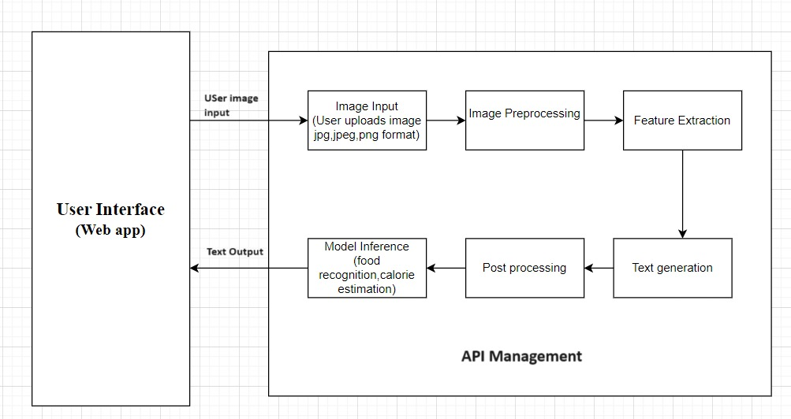

# METHODOLOGY:

Methodologies for Calorie Advisor Application with Gemini Pro Vision.

This section outlines the key methodologies involved in developing a Calorie Advisor Application leveraging Gemini Pro Vision:

1. **Data Aquisition and preparation:**

Food Image Dataset:

Collect a large number of professional food photographs in terms of cuisines, dishes, food items and serving size and method.Use datasets that are available in the open domain or generate in your own using controlled photo shoots.Make sure that the dataset depicts what the target users eat.

Calorie Label Assignment:

For each image in the dataset, the calorie count of the image is supposed to be labeled.For accurate calorie labeling use food databases from the US Department of Agriculture or work with registered dietitians.

Data Pre-processing:

Train the model using images that have been pre-processed effectively.This may include

resizing, cropping, color correction, and background processing.

## Gemini Pro Vision Integration:

API Utilization:

Use Gemini Pro Vision’s API to identify food items right within the app.Design neat API requests to examine the food pictures provided by users.It is desirable that the API returns identified food items and their confidence in response.

Model Deployment:

You might also look at deploying a food recognition model using Gemini Pro Vision as part of your application based on your development strategy.

This would include knowledge of model deployment mechanisms and maybe even the optimization of model processing on mobile applications.

## Calorie Estimation and Tracking:

Calorie Database Integration:

This includes using a calorific food listing system with your application.This database should track the food items that are identified from Gemini Pro Vision to the total calories of the specific food items.Investigate the opportunity to connect with a pre-existing food database or create a new one using credible resources.

Calorie Calculation:

All the food items from Gemini Pro Vision have been recognized.

Calorie information from the integrated database: Calories.Correspondent comments by users on size of portions (if relevant).

Tracking and Analytics:

Develop mechanisms to monitor the count of calories consumed on a daily or weekly basis through the use of logs or application usage.Create graphical reports for users to track their health and progress in dieting.

Optimization: Connect with devices or platforms that provide information on overall calorie consumption and burn.

## Handling Uncertainty and Error:

Confidence Scores:

Use the confidence scores produced by the food recognition in Gemini Pro Vision to estimate the confidence in the classification results.

Develop methods to deal with the situations with the low confidence scores (e. g. without deleting it, asking the user to confirm the deletion, or offering related products).

Calorie Estimation Error:

Admit that any calculation of the calorie content of the dish based on artificial intelligence is imperfect.

## User-Interface(UI) design:

Intuitive Interface:

Create a visually appealing and easy-to-navigate UI that enables users to take pictures or upload photos of food, see proposed items, and access nutrition information.Make sure the interface is well designed and allows for as pleasant as possible user experience.

Ensure the user is suggested proper visual and text feedback to point to food items, confidence scores, and total calorie count.Also provide ways through which the users can review, update, or approve identifications.

## Evaluation and Testing:

Accuracy Testing:The ability of the app to predict the food and estimate calories must be assessed using a different testing dataset.Evaluate how the application is compared to other calorie tracking options. Run it on users to get their feedback on usability, what main features they like, and their overall impression of the UX.Thus, the application needs to be enhanced based on user feedback to ensure that the application is appropriate for the users’ needs.All these methodologies can be followed to build a reliable and user-friendly Calorie Advisor Application that will use the power of Gemini Pro Vision for food recognition as well as calorie estimation. Your application should evolve to meet the expectations of the users as well as to explore the new opportunities that AI technologies present.

**RESULT:**

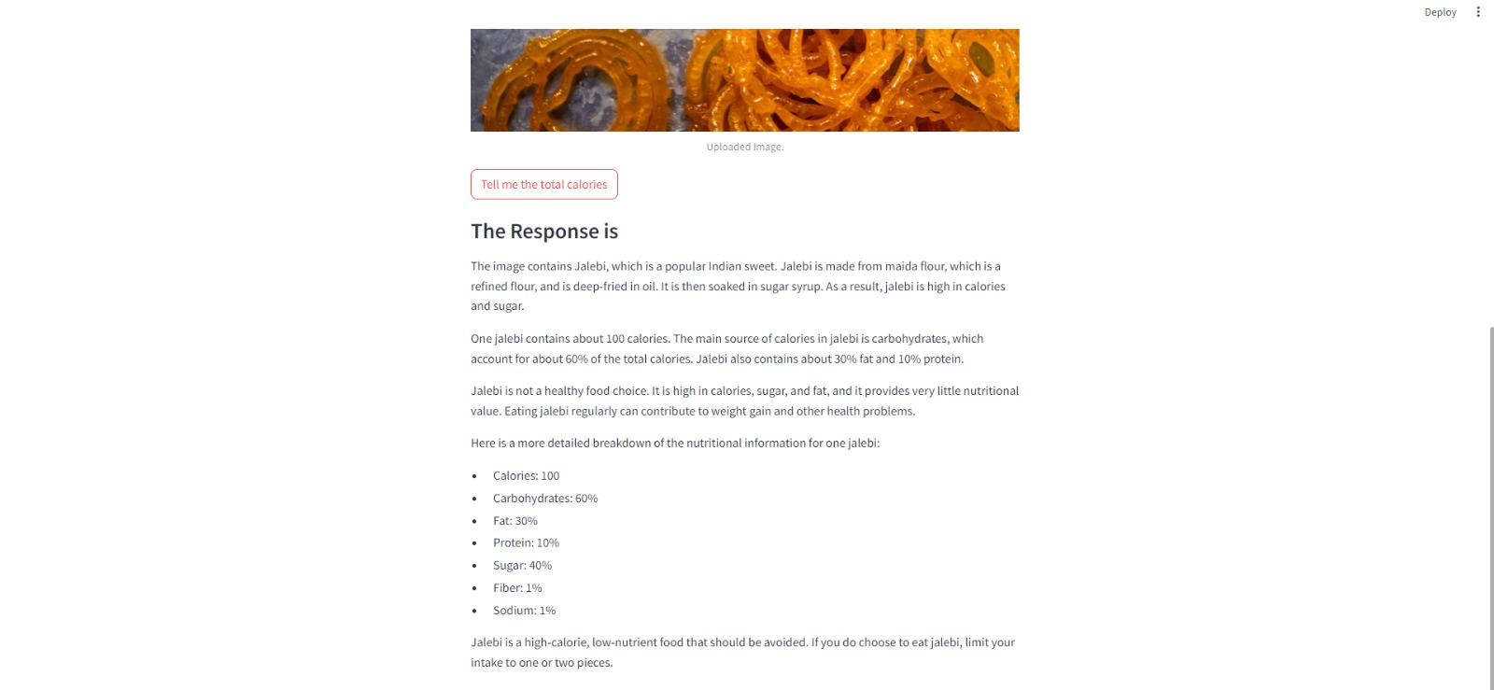

**REFERNCES:**

1. [Hall KD, Bemis T, Brychta R, Chen KY,](https://pubmed.ncbi.nlm.nih.gov/26278052/) [Courville A, Crayner EJ, Goodwin S, Guo J,](https://pubmed.ncbi.nlm.nih.gov/26278052/) [Howard L, Knuth ND, Miller BV 3rd, Prado](https://pubmed.ncbi.nlm.nih.gov/26278052/) [CM, Siervo M, Skarulis MC, Walter M, Walter](https://pubmed.ncbi.nlm.nih.gov/26278052/) [PJ, Yannai L. Calorie for Calorie, Dietary Fat](https://pubmed.ncbi.nlm.nih.gov/26278052/) [Restriction Results in More Body Fat Loss than](https://pubmed.ncbi.nlm.nih.gov/26278052/) [Carbohydrate Restriction in People with](https://pubmed.ncbi.nlm.nih.gov/26278052/) [Obesity. Cell Metab. 2015 Sep 1;22(3):427-36.](https://pubmed.ncbi.nlm.nih.gov/26278052/) [doi: 10.1016/j.cmet.2015.07.021. Epub 2015](https://pubmed.ncbi.nlm.nih.gov/26278052/) [Aug 13. PMID: 26278052; PMCID:](https://pubmed.ncbi.nlm.nih.gov/26278052/) [PMC4603544.](https://pubmed.ncbi.nlm.nih.gov/26278052/)
2. [https://www.researchgate.net/publication/3783](https://www.researchgate.net/publication/378393097_Public_acceptance_of_using_artificial_intelligence-assisted_weight_management_apps_in_high-income_southeast_Asian_adults_with_overweight_and_obesity_a_cross-sectional_study) [93097_Public_acceptance_of_using_artificial_in](https://www.researchgate.net/publication/378393097_Public_acceptance_of_using_artificial_intelligence-assisted_weight_management_apps_in_high-income_southeast_Asian_adults_with_overweight_and_obesity_a_cross-sectional_study) [telligence-assisted_weight_management_apps_i](https://www.researchgate.net/publication/378393097_Public_acceptance_of_using_artificial_intelligence-assisted_weight_management_apps_in_high-income_southeast_Asian_adults_with_overweight_and_obesity_a_cross-sectional_study) [n_high-income_southeast_Asian_adults_with_o](https://www.researchgate.net/publication/378393097_Public_acceptance_of_using_artificial_intelligence-assisted_weight_management_apps_in_high-income_southeast_Asian_adults_with_overweight_and_obesity_a_cross-sectional_study) [verweight_and_obesity_a_cross-sectional_study](https://www.researchgate.net/publication/378393097_Public_acceptance_of_using_artificial_intelligence-assisted_weight_management_apps_in_high-income_southeast_Asian_adults_with_overweight_and_obesity_a_cross-sectional_study)
3. [https://www.karinainkster.com/post/food-logging-pros-and-cons-of-myfitnesspal#:~:text=Basel](https://www.karinainkster.com/post/food-logging-pros-and-cons-of-myfitnesspal#%3A~%3Atext%3DBaseline%20calories%20are%20often%20underestimated%2Cnumber%20is%20upwards%20of%203000) [ine%20calories%20are%20often%20underestim](https://www.karinainkster.com/post/food-logging-pros-and-cons-of-myfitnesspal#%3A~%3Atext%3DBaseline%20calories%20are%20often%20underestimated%2Cnumber%20is%20upwards%20of%203000) [ated,number%20is%20upwards%20of%203000.](https://www.karinainkster.com/post/food-logging-pros-and-cons-of-myfitnesspal#%3A~%3Atext%3DBaseline%20calories%20are%20often%20underestimated%2Cnumber%20is%20upwards%20of%203000)
4. [https://www.healthline.com/nutrition/noom-die](https://www.healthline.com/nutrition/noom-diet-review#recommendation) [t-review#recommendation](https://www.healthline.com/nutrition/noom-diet-review#recommendation)
5. [https://www.researchgate.net/publication/377963001_Effect_of_FatSecret_App_Implementatio](https://www.researchgate.net/publication/377963001_Effect_of_FatSecret_App_Implementation_on_Increased_Physical_Activity_and_Weight_Loss) [n_on_Increased_Physical_Activity_and_Weight](https://www.researchgate.net/publication/377963001_Effect_of_FatSecret_App_Implementation_on_Increased_Physical_Activity_and_Weight_Loss)

[_Loss](https://www.researchgate.net/publication/377963001_Effect_of_FatSecret_App_Implementation_on_Increased_Physical_Activity_and_Weight_Loss)

1. [https://www.researchgate.net/publication/379171804_Gemini_or_ChatGPT_Capability_Perfor](https://www.researchgate.net/publication/379171804_Gemini_or_ChatGPT_Capability_Performance_and_Selection_of_Cutting-edge_Generative_Artificial_Intelligence_AI_in_Business_Management) [mance_and_Selection_of_Cutting-edge_Generat](https://www.researchgate.net/publication/379171804_Gemini_or_ChatGPT_Capability_Performance_and_Selection_of_Cutting-edge_Generative_Artificial_Intelligence_AI_in_Business_Management) [ive_Artificial_Intelligence_AI_in_Business_Ma](https://www.researchgate.net/publication/379171804_Gemini_or_ChatGPT_Capability_Performance_and_Selection_of_Cutting-edge_Generative_Artificial_Intelligence_AI_in_Business_Management) [nagement](https://www.researchgate.net/publication/379171804_Gemini_or_ChatGPT_Capability_Performance_and_Selection_of_Cutting-edge_Generative_Artificial_Intelligence_AI_in_Business_Management)
2. [https://assets.bwbx.io/documents/users/iqjWH](https://assets.bwbx.io/documents/users/iqjWHBFdfxIU/r7G7RrtT6rnM/v0) [BFdfxIU/r7G7RrtT6rnM/v0](https://assets.bwbx.io/documents/users/iqjWHBFdfxIU/r7G7RrtT6rnM/v0)
3. [https://cloud.google.com/bigquery/docs/image](https://cloud.google.com/bigquery/docs/image-analysis)

[-analysis](https://cloud.google.com/bigquery/docs/image-analysis)

1. <https://www.researchgate.net/publication/3191>[64243_Natural_Language_Processing_State_of_](https://www.researchgate.net/publication/319164243_Natural_Language_Processing_State_of_The_Art_Current_Trends_and_Challenges) [The_Art_Current_Trends_and_Challenges](https://www.researchgate.net/publication/319164243_Natural_Language_Processing_State_of_The_Art_Current_Trends_and_Challenges)
2. <https://www.jmlr.org/papers/volume12/collobert11a/collobert11a.pdf>
3. [https://www.researchgate.net/publication/377](https://www.researchgate.net/publication/377530197_Multimodal_analysis) [530197_Multimodal_analysis](https://www.researchgate.net/publication/377530197_Multimodal_analysis)
4. <https://ieeexplore.ieee.org/document/8269806>
5. [https://www.researchgate.net/publication/361](https://www.researchgate.net/publication/361136117_A_Survey_on_IBM_Watson_and_Its_Services) [136117_A_Survey_on_IBM_Watson_and_Its_S](https://www.researchgate.net/publication/361136117_A_Survey_on_IBM_Watson_and_Its_Services) [ervices](https://www.researchgate.net/publication/361136117_A_Survey_on_IBM_Watson_and_Its_Services)
6. [https://www.researchgate.net/publication/346](https://www.researchgate.net/publication/346111006_Overview_of_the_Transformer-based_Models_for_NLP_Tasks) [111006_Overview_of_the_Transformer-based_](https://www.researchgate.net/publication/346111006_Overview_of_the_Transformer-based_Models_for_NLP_Tasks) [Models_for_NLP_Tasks](https://www.researchgate.net/publication/346111006_Overview_of_the_Transformer-based_Models_for_NLP_Tasks)
7. [https://ieeexplore.ieee.org/abstract/document/](https://ieeexplore.ieee.org/abstract/document/9222960) [9222960](https://ieeexplore.ieee.org/abstract/document/9222960)
8. [https://www.ncbi.nlm.nih.gov/pmc/articles/P](https://www.ncbi.nlm.nih.gov/pmc/articles/PMC10874304/) [MC10874304/](https://www.ncbi.nlm.nih.gov/pmc/articles/PMC10874304/)
9. <https://www.sciencedirect.com/science/article/pii/S2666827022000445>
10. [https://www.researchgate.net/publication/376812352_Welcome_to_the_Gemini_era_Google_](https://www.researchgate.net/publication/376812352_Welcome_to_the_Gemini_era_Google_DeepMind_and_the_Information_Industry) [DeepMind_and_the_Information_Industry](https://www.researchgate.net/publication/376812352_Welcome_to_the_Gemini_era_Google_DeepMind_and_the_Information_Industry)
11. [https://www.researchgate.net/publication/335830561_The_Effect_of_Nano_Gemini_Ionic_Li](https://www.researchgate.net/publication/335830561_The_Effect_of_Nano_Gemini_Ionic_Liquid_Type_Surfactant_on_Interfacial_Tension_for_Enhanced_Oil_Recovery) [quid_Type_Surfactant_on_Interfacial_Tension_f](https://www.researchgate.net/publication/335830561_The_Effect_of_Nano_Gemini_Ionic_Liquid_Type_Surfactant_on_Interfacial_Tension_for_Enhanced_Oil_Recovery) [or_Enhanced_Oil_Recovery](https://www.researchgate.net/publication/335830561_The_Effect_of_Nano_Gemini_Ionic_Liquid_Type_Surfactant_on_Interfacial_Tension_for_Enhanced_Oil_Recovery)
12. [https://blog.roboflow.com/gemini-what-we-k](https://blog.roboflow.com/gemini-what-we-know/) [now/](https://blog.roboflow.com/gemini-what-we-know/)
13. [https://compass.onlinelibrary.wiley.com/doi/a](https://compass.onlinelibrary.wiley.com/doi/abs/10.1111/spc3.12731) [bs/10.1111/spc3.12731](https://compass.onlinelibrary.wiley.com/doi/abs/10.1111/spc3.12731)
14. https://ieeexplore.ieee.org/abstract/document/[10169703](https://ieeexplore.ieee.org/abstract/document/10169703)
15. <https://sifisheriessciences.com/journal/index.> [php/journal/article/view/1328](https://sifisheriessciences.com/journal/index.php/journal/article/view/1328)
16. [https://www.proquest.com/openview/eeec52d](https://www.proquest.com/openview/eeec52dcd5523b220544e6cf96bcef22/1?pq-origsite=gscholar&cbl=5314840) [cd5523b220544e6cf96bcef22/1?pq-origsite=gsc](https://www.proquest.com/openview/eeec52dcd5523b220544e6cf96bcef22/1?pq-origsite=gscholar&cbl=5314840) [holar&cbl=5314840](https://www.proquest.com/openview/eeec52dcd5523b220544e6cf96bcef22/1?pq-origsite=gscholar&cbl=5314840)
17. [https://medium.com/google-developer-expert](https://medium.com/google-developer-experts/unlock-your-ideas-with-gemini-hands-on-guide-8638b1402dd9) [s/unlock-your-ideas-with-gemini-hands-on-guid](https://medium.com/google-developer-experts/unlock-your-ideas-with-gemini-hands-on-guide-8638b1402dd9) [e-8638b1402dd9](https://medium.com/google-developer-experts/unlock-your-ideas-with-gemini-hands-on-guide-8638b1402dd9)